|  |  |
| --- | --- |
| **Homework 1** | **Chapter 3 – Selections**  **Chapter 4 – Mathematical Functions, Characters and Strings**  **Chapter 5 – Loops**  **Chapter 6 - Methods** |
| **Due June 3 at 11:30 pm** | **Objectives**  ■ To declare **boolean** variables and write Boolean expressions using relational operators  ■ To implement selection control using one-way **if** statements  ■ To implement selection control using two-way **if-else** statements  ■ To implement selection control using nested **if** and multi-way **if** statements  ■ To avoid common errors and pitfalls in **if** statements  ■ To generate random numbers using the **Math.random()** method  ■ To combine conditions using logical operators (**!**, **&&**, **||**, and **^**)  ■ To program using selection statements with combined conditions  ■ To solve mathematical problems by using the methods in the Math class  ■ To represent characters using the char type  ■ To encode characters using ASCII and Unicode  ■ To represent strings using the String object |

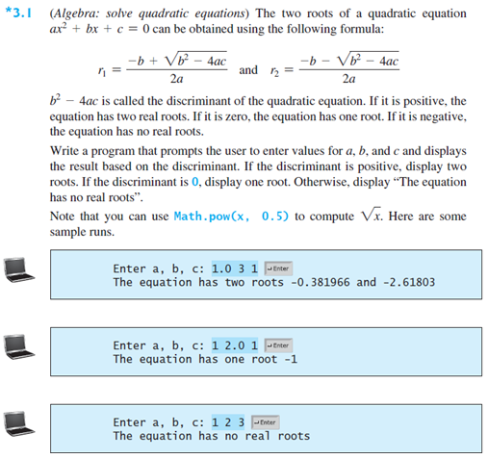

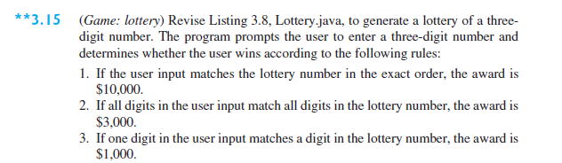

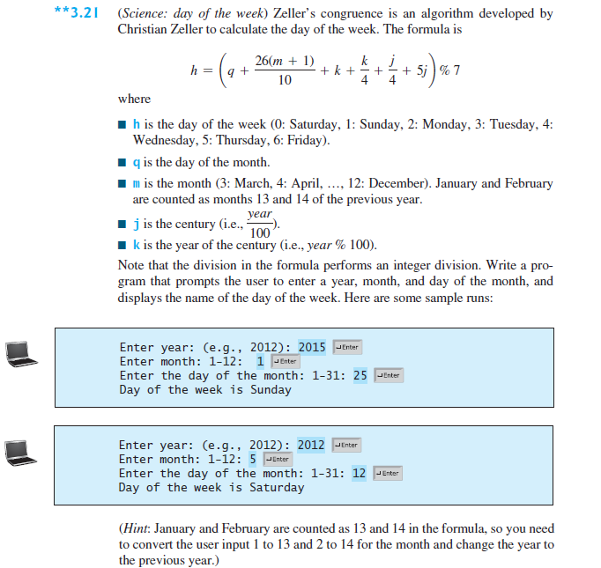

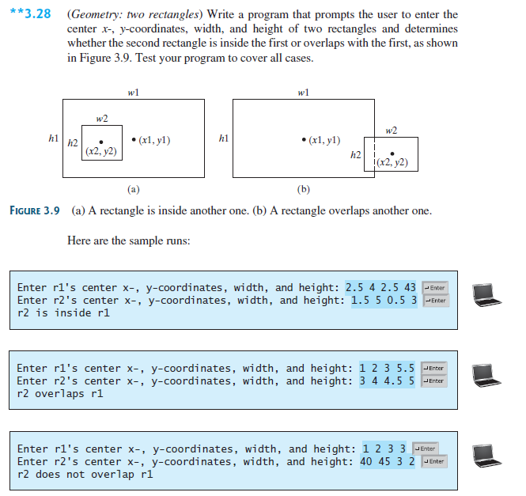

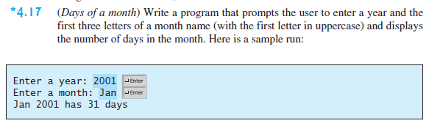

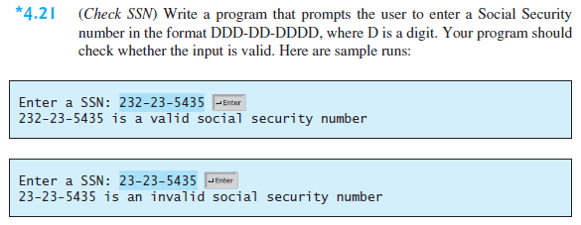

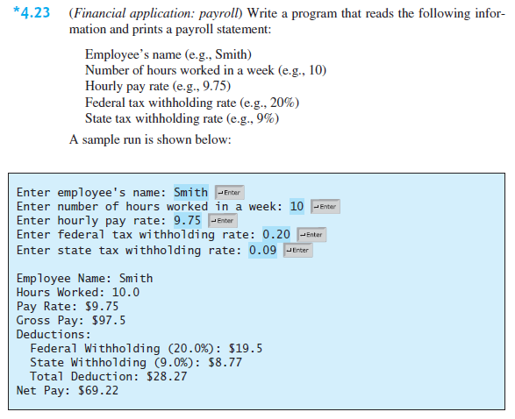

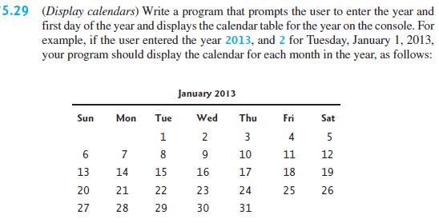

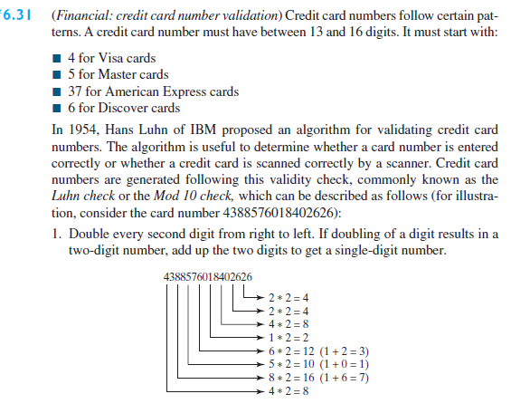

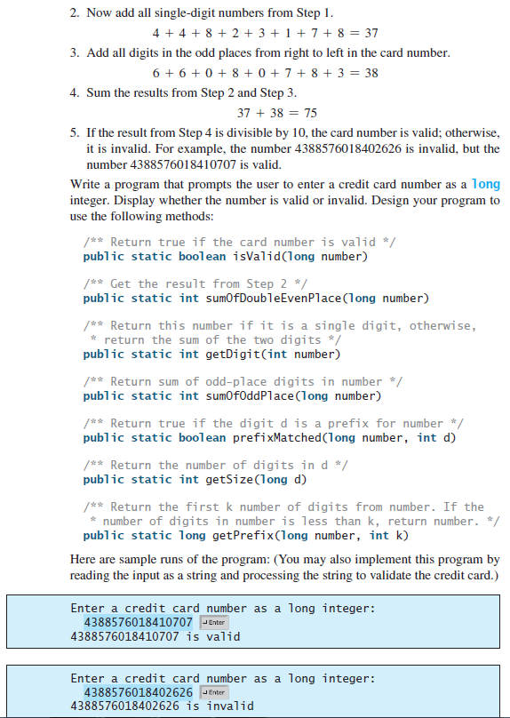

## Task List

You are required to complete the following activities by the deadlines specified and submit the appropriate *deliverables* through eLearning.

|  |  |
| --- | --- |
| Activity | Deadline |
| Create Class Files having its own main method for each of the problems in this assignment. ________________________________________________  Compile, Execute and Test your program | June 3 at 11:30 pm |
| Zip the Java Files and submit on eLearning |

## Guidelines

You will be graded according to the following guidelines:

* You are required to submit files through eLearning by the specified deadline. You can earn a maximum of 100 points.
* If the files do not compile, you will receive a 0 for the program.
* You are graded primarily on the design of your class and the adequate testing of your class. Poor design or inadequate testing will result in loss of points.
* Your files should be adequately commented. Up to -15 points will be deducted for poor indentation and documentation.